1. 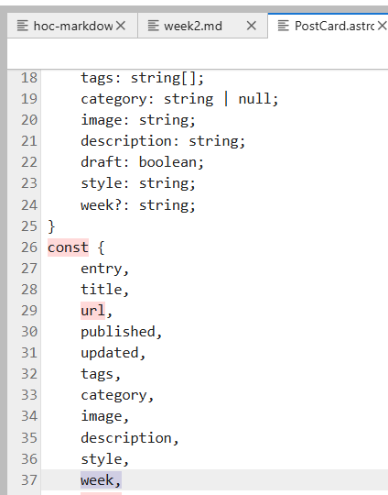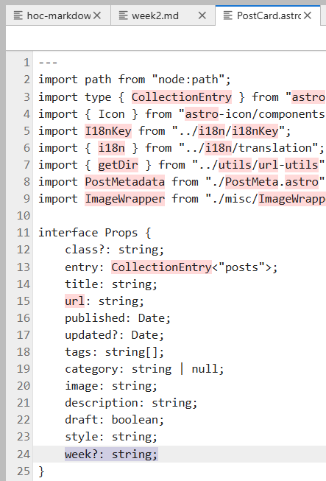Vào file src/components/Postcard.astro thêm giá trị week sau:
2. Sửa lại nội dung postpage.astro

---

import type { CollectionEntry } from "astro:content";

import { getPostUrlBySlug } from "@utils/url-utils";

import PostCard from "./PostCard.astro";

const { page } = Astro.props;

// Lấy danh sách các tuần duy nhất từ dữ liệu bài viết

const weekSet = new Set<string>();

page.data.forEach((entry) => {

if (entry.data.week) {

weekSet.add(entry.data.week);

}

});

const weeks = Array.from(weekSet).sort(); // sắp xếp nếu muốn

let delay = 0;

const interval = 50;

---

<!-- Tự động tạo các nút tuần -->

<div class="flex gap-2 mb-4">

<button onclick="filterWeek('all')" class="px-3 py-1 bg-gray-200 rounded">Tất cả</button>

{weeks.map((w) => (

<button onclick={`filterWeek('${w}')`} class="px-3 py-1 bg-gray-200 rounded">

{w.replace("week-", "Week ")}

</button>

))}

</div>

<!-- Danh sách bài viết -->

<div id="posts-wrapper" class="transition flex flex-col rounded-[var(--radius-large)] bg-[var(--card-bg)] py-1 md:py-0 md:bg-transparent md:gap-4 mb-4">

{page.data.map((entry: CollectionEntry<"posts">) => (

<div class="post-wrapper" data-week={entry.data.week || "none"}>

<PostCard

entry={entry}

title={entry.data.title}

tags={entry.data.tags}

category={entry.data.category}

published={entry.data.published}

updated={entry.data.updated}

url={getPostUrlBySlug(entry.slug)}

image={entry.data.image}

description={entry.data.description}

draft={entry.data.draft}

class:list="onload-animation"

style={`animation-delay: calc(var(--content-delay) + ${delay++ * interval}ms);`}

week={entry.data.week}

/>

</div>

))}

</div>

<!-- Script lọc -->

<script is:inline>

function filterWeek(week) {

const posts = document.querySelectorAll(".post-wrapper");

posts.forEach((post) => {

const postWeek = post.getAttribute("data-week");

if (week === "all" || postWeek === week) {

post.style.display = "block";

} else {

post.style.display = "none";

}

});

}

</script>

3.Vào file src/content/config.ts, thêm đoạn sau:

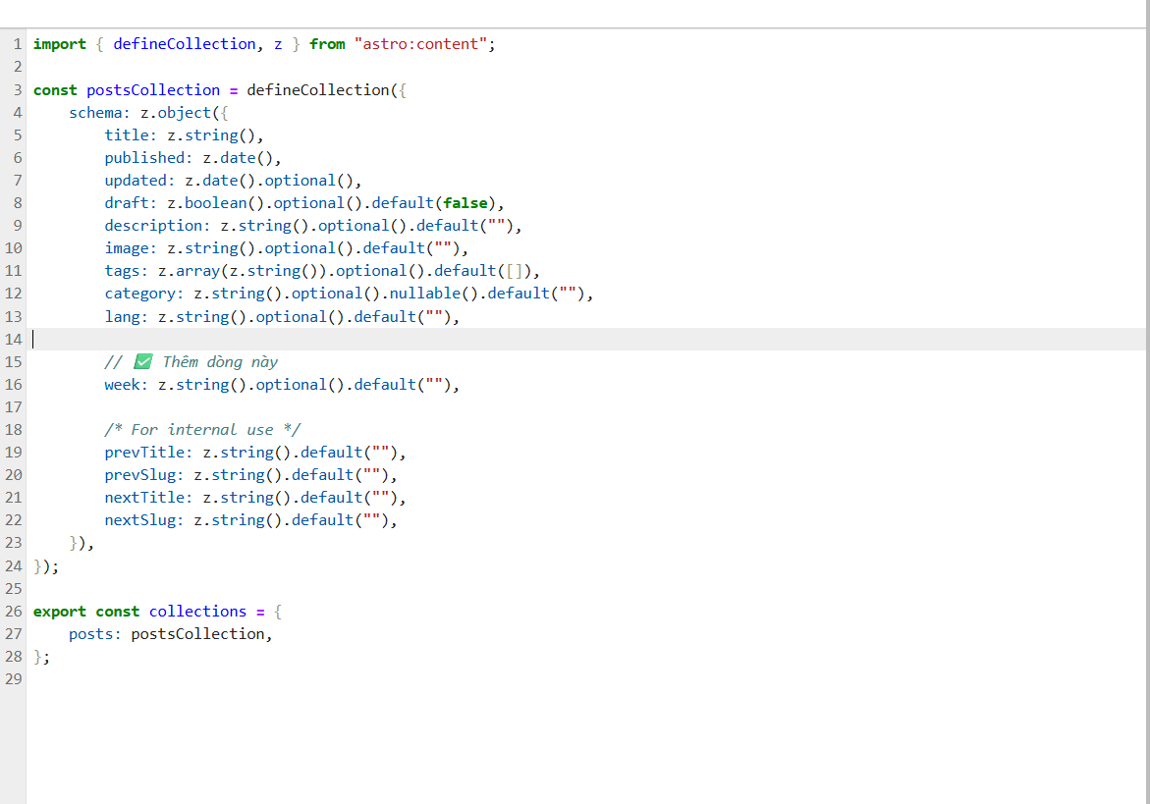

4.Thêm week: “week-…” vào từng bài post theo từng tuần

site: "https://tommytriet.github.io",

base: "/AI_project",